PC View POS

Installation Guide

If normal installation does not work. Follow below Steps.

** YOU NEED TO START 'XAMPP' BEFORE RUNNING THE SOFTWARE EACHTIME**

1. Please install java before installing this software.

Link - <https://www.java.com/en/download/>

1. Please install XAMPP, run XAMPP, go to localhost, log into phpMyAdmin using Username - ‘root’ and Password – ‘’ choose MySQL as Database and import the 'pcview' sql file from the 'DB SQL' folder into phpMyAdmin MySQL Database.

XAMPP Download link - <https://www.apachefriends.org/index.html>

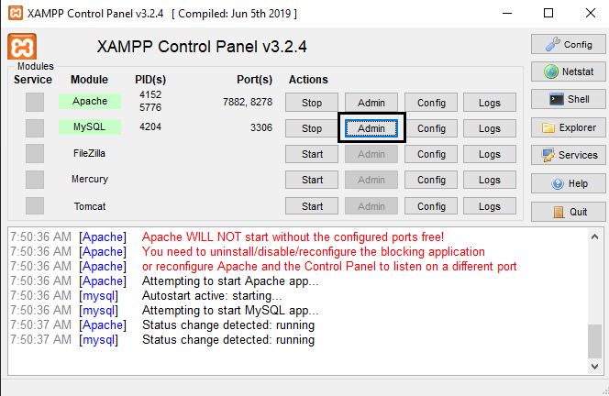

Figure ‑: Click admin to go to Localhost

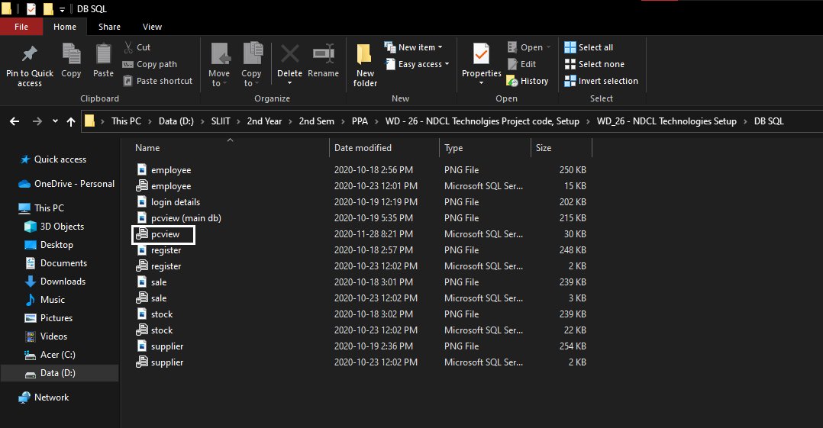

Figure ‑: 'pcview' sql file in ‘DB SQL’ folder

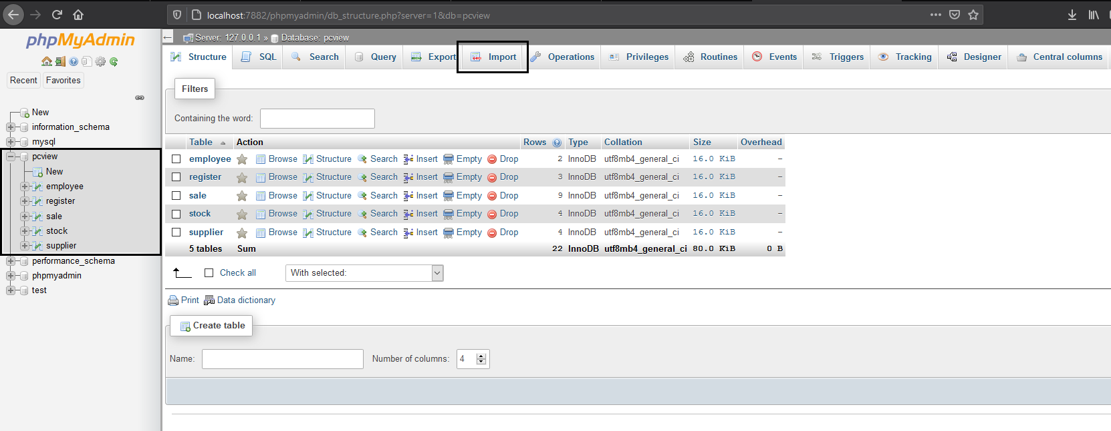

Figure ‑: Import 'pcview' sql file into the Database

1. After the above steps, Run the PC View POS Setup.

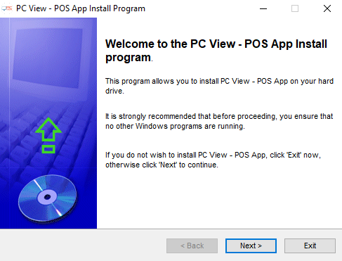

Click Next to Continue.

1. Agree with terms and conditions and click next

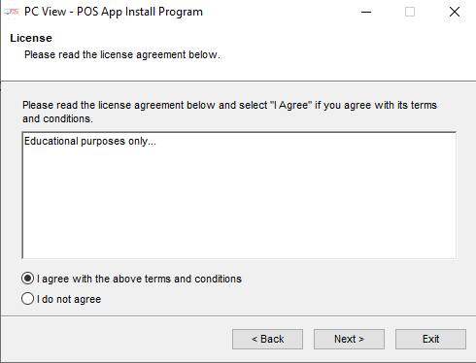

1. Create a New folder inside the 'dist' folder (**‘dist’ is a folder inside the project folder 'PCView_POS'**) and Give installation path to it.



1. Complete the installation.
2. Use the shortcut 'PC View POS' in the desktop to run the software.



1. If the shortcut was not created in the Desktop, please use the exe file inside the installed folder to run the software.
2. Login page looks like this.

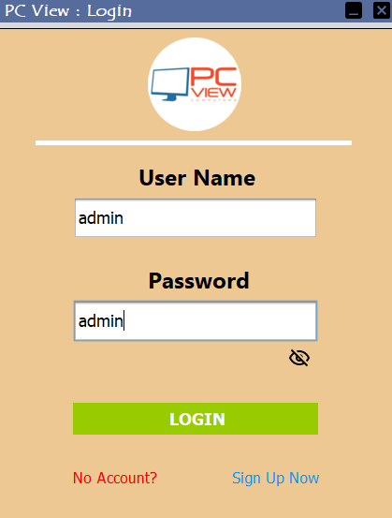

\*\***Use one of the below login credentials or create a new account to login**\*\*

Username - **admin**

Password - **admin**

Username - **user1**

Password - **user1**

Username - **pcman**

Password – **pcman**

1. Software looks like this. Enjoy.

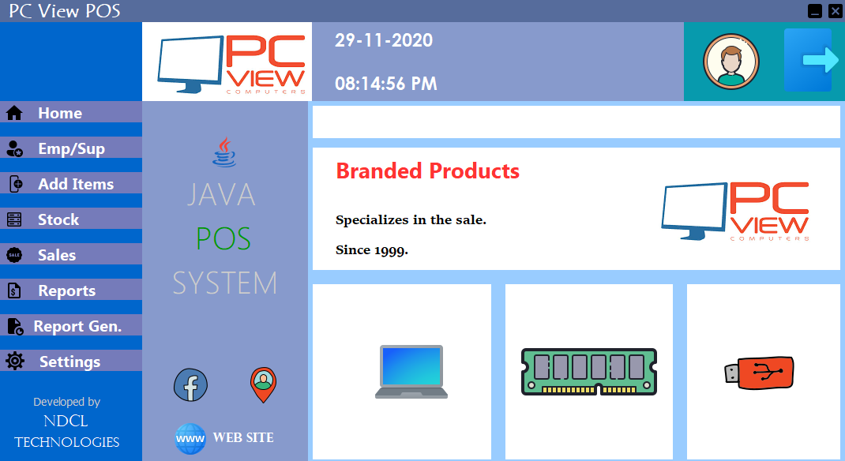

Thank You for using NDCL Technologies Products

Contact Us if installation failed.

Nimesh - 0778275983 / nimeshfernandz6@gmail.com